EXPERIMENT 1: - Create a simple cloud software application for Flight Reservation System using any Cloud Service Provider to demonstrate SaaS

Step 1: - Go to ZOHO.com

Step 2: - Create an account and log in

Step 3: - Create an application

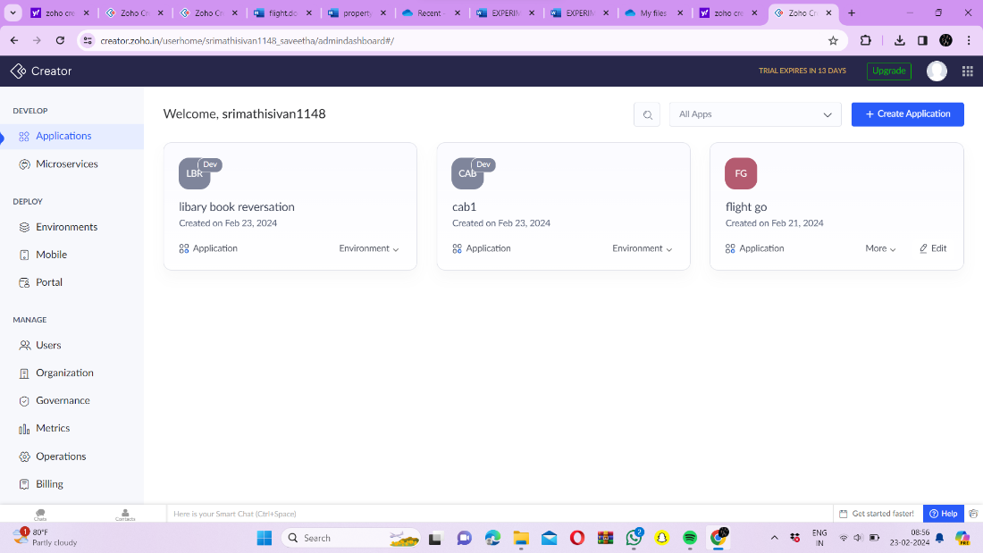

Step 4: - Create login form

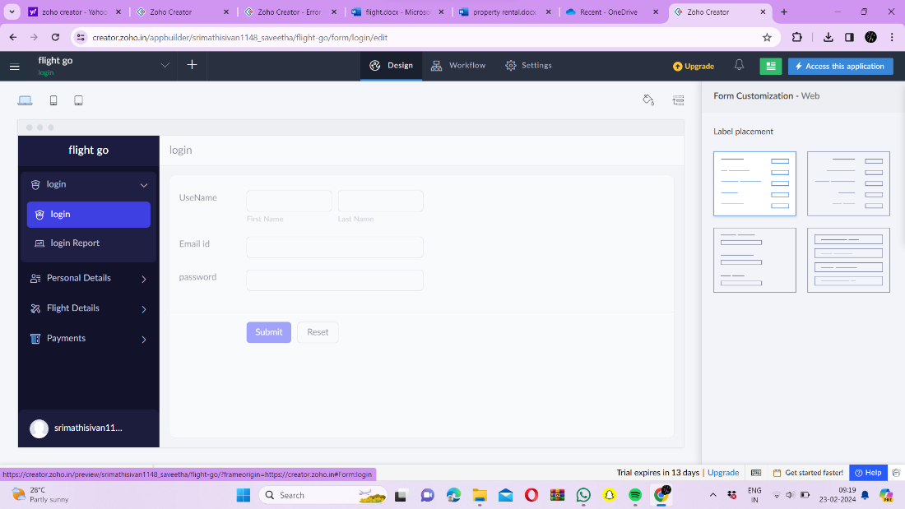

Step 5: - Create the second form to get further details of travel

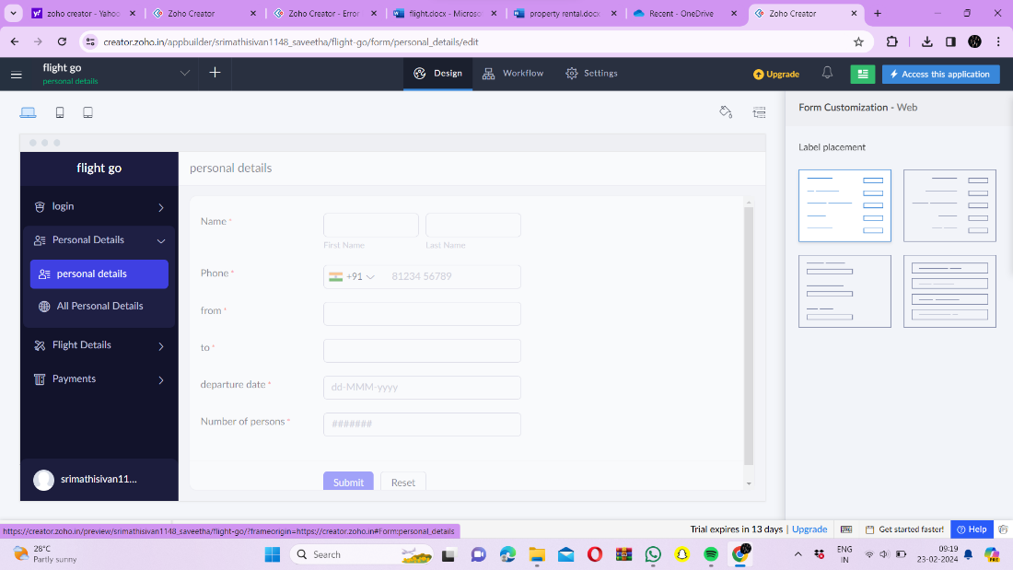

Step 6: - Create third form to get details of the flight

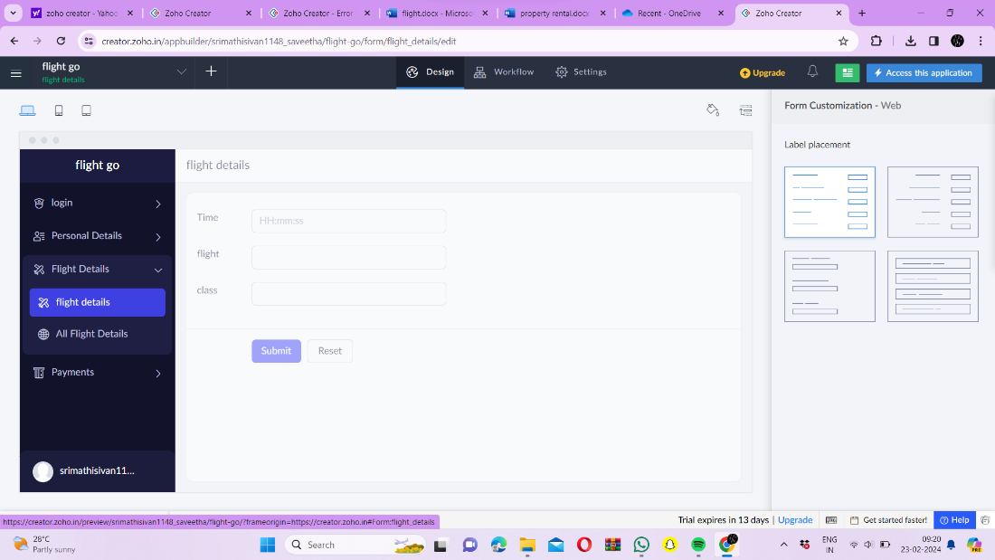

Step 7: - Create Payment form

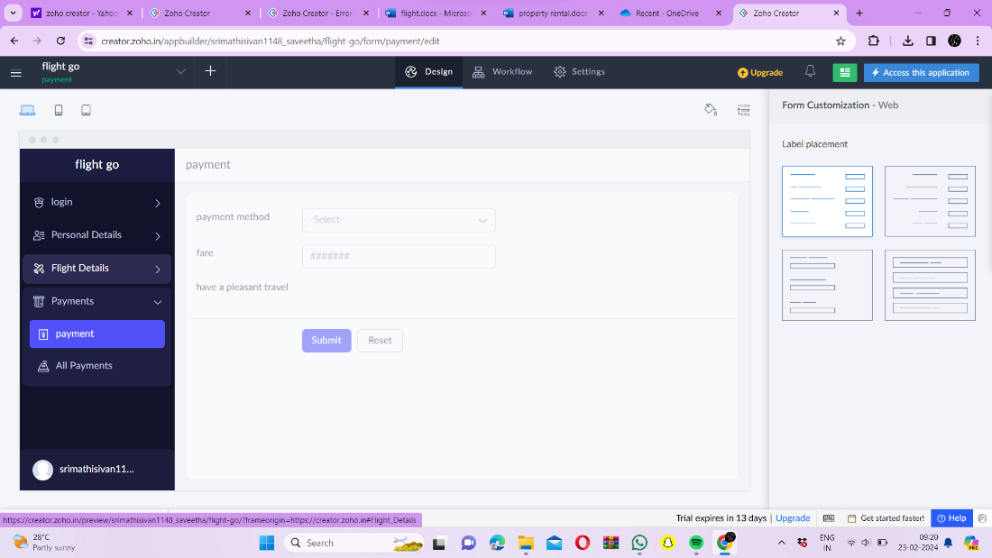

Step 8: - Click the Access Development Live to see the output

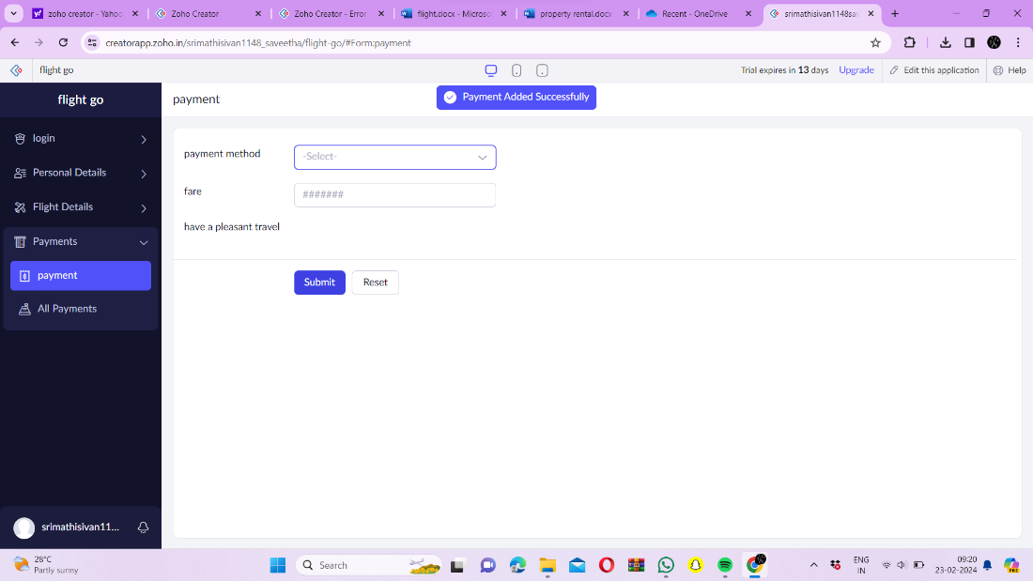

Step 9: - Click the login report to see the data

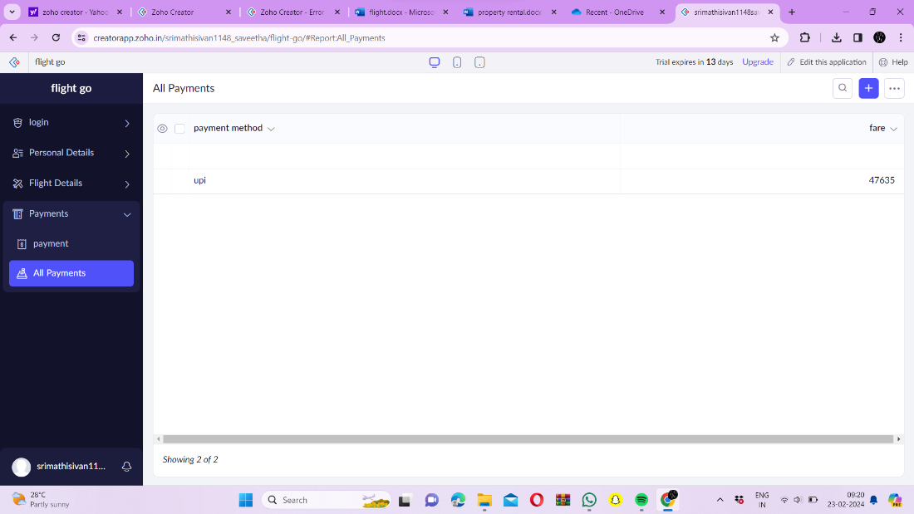

Step 10: - Click on the mobile icon to see mobile output.

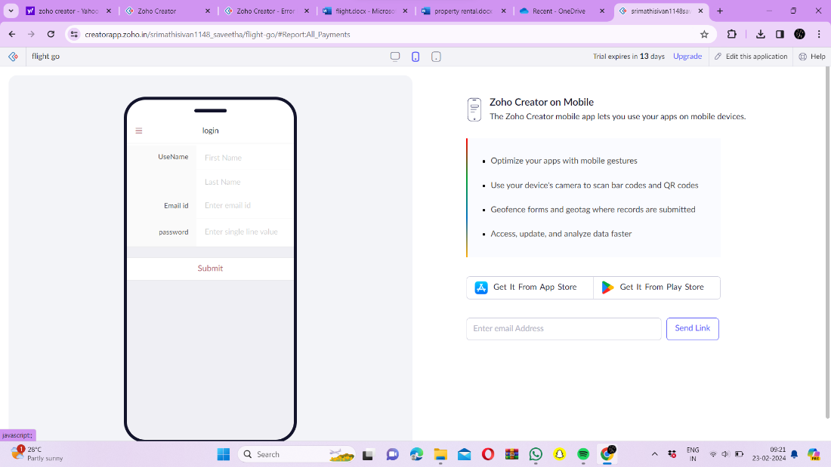

Step 11: - Click on the tablet icon to see tablet output.

